Annual Examination [2023-24]
Class –IX [Social Science] Date: 5/03/2024 Time: 3Hrs. MM: 80

General Instructions:
- Question paper comprises 6 sections A, B, C, D, E & F.
- There are 37 questions in the question paper. All questions are compulsory.
- Section A Q1 to Q20 MCQ carrying 1 marks each.
- Section B Q 21 to Q24 VERY SHORT QUESTIONS carrying 2 marks each.
- Section C contains Q25 to Q 29 SHORT QUESTION carrying 3 marks each
- Section D Q30 to Q33 are LONG QUESTIONS carrying 5 marks each.
- Section E - Q 34 to Q36 CASE BASED QUESTIONS carry 4 marks each.
- Section F- Q37 MAP BASED QUESTION carrying 5 marks with two parts 37a from history (2 marks) and 37 b from geography (3 marks.)
- There is no overall choice in the question paper however an internal choice has been provided in few questions.
Section-A
- Multiple Choice Questions :- (20*1=20)
1. The famous slogan of the French Revolution was:
a) Liberty, Equality, Fraternity b) No Taxation without Representation
c) E Pluribus Unum d) Give me liberty or give me death
2. What was the main aim of Hitler's foreign policy, which led to the outbreak of World War II?
a) Expansion of socialism b) Creation of a European Union
c) Pursuit of world peace d) Expansion of German territory (Lebensraum)
3. The northernmost point of India is in:
a) Jammu and Kashmir b) Punjab c) Uttarakhand d) Himachal Pradesh
4. The largest freshwater lake in India is:
a) Dal Lake b) Chilika Lake c) Vembanad Lake d) Wular Lake
5. . ___________ refers to the sum total of weather conditions and variations over a large area for a long period of time (more than thirty years).
a) Weather b) Climate c) Season d) Temperature
6. Which of the following is not a method of conservation of wildlife?
a) Habitat preservation b) Wildlife reserves c) Deforestation d) Captive breeding
7. What is the importance of the concept of political equality in a democracy?
a) It ensures equal distribution of wealth among citizens.
b) It guarantees religious freedom for all citizens.
c) It ensures that every citizen has an equal right to vote and participate in decision-making.
d) It promotes economic development and prosperity.
8. What is the purpose of the Election Commission of India?
a) To conduct elections in a free and fair manner b) To promote the ruling party's agenda
c) To distribute election funds to political parties d) To enforce the code of conduct for candidates
9.Which of the following about the president is wrong?
a)He is the head of the state. b) He is the highest formal authority in the country
c)He exercises only nominal powers. d) He is directly elected by the people.
10. Which of the following is not a form of social inequality?
a) Caste discrimination b) Gender inequality c) Linguistic diversity d) Economic disparities
11.Investment in human capital can be made through:-
a) Education b)Skill c)Training d)All the three
12. What does AAY (a government scheme) stand for?
a) Antyodaya Awaas Yojana b) Antyodaya Aayush Yozana
c)Antyodaya Anna Yozana d)None of the above
13. The most devastating famine occurred in Bengal in
(a) 1938 (b) 1940 (c) 1942 (d) 1943
14. What is the role of the government in poverty alleviation?
a) Providing direct cash transfers to the poor
b) Offering free healthcare to the poor
c) Implementing policies and programs to reduce poverty
d) Leaving poverty alleviation solely to non-governmental organizations
15.Match the following:-
List I List II
A. Louis XVI became the king of France i. 1789
B. Third estate forms National Assembly ii.1792-93
C. Robespierre is guillotined iii.1774
D. France became a republic iv.1794
a) i,iii,ii,iv b) iii,i,iv,ii c)iv,i,iii,ii d)ii,iii,iv,i
16. Match the following:-
List I(Rivers) List II(Tributatries)
A Indus i.Yamuna
B. ganga ii.Satluj
C. brahmaputra iii.Manjra
D. Godavari iv.Dibang
a)ii,I,iv,iii b)iv,iii,ii,I c)iv, iii,i,ii d)iii,iv,ii,i
Assertion and Reason:
a.Both (A) and (R) are true and (R) is the correct explanation of (A) .
b.Both (A) and (R) are true but (R) is not the correct explanation of (A) .
c. (A) is true but (R) is false.
d. (A) is false but (R) is true.
17. Assertion (A): The Liberals wanted to Safeguard the rights of individuals against government.
Reason (R): They wanted a nation in which government was based on the majority of a country’s population.
18. Assertion : The proportion of people working in different activities varies in developed and developing contries.
Reason: Developed countries have a higher proportion of their work force engaged in primary activities.
19. Assertion: India adopted a federal system of government after independence.
Reason: India is a vast country with diverse cultures, languages and regions.
20.Assertion(A) :- Urban areas have mostly educated unemployment.
Reason(R);-Many youth with matriculation, graduation and Post Graduation degrees are not able to find jobs.
Section-B
21. What is the role of education in human capital formation?
22. Quite a few species of plants and animals are endangered in India. Why?
23. What do you understand by the term “Reign of Terror”?
24. What is the significance of the “Preamble” to the Indian Constitution?
Section-C
25. Explain how the schooling was done under Nazism.
26. Describe the basic factors affecting the population of India.
27. Why do we need Parliament?
OR
Mention the difference between political executive and permanent executive.
28. Mention the three specific evils declared as illegal by the Constitution?
29. How is food security affected during calamity?
OR
What are the three dimensions of food security.
Section – D
30. What was the effects of Great Depression on Germany.
OR
What is the role of women in Nazi Society?
31. Mention the features of cold season.
OR
Mention the significant features of NPP2000.
32. The right to freedom is actually a cluster of several right. Analyse.
OR
Mention the powers and functions of Prime Minister.
33. How to security is insured India?
OR
Mention the malpractices done in ration shops.
Section-E
34. Read the source given below and answer the following questions:-
The Bolsheviks were totally opposed to private property. Most industry and banks were nationalised in November 1917. This meant that the government took over ownership and management. Land was declared social property and peasants were allowed to seize the land of the nobility. In cities, Bolsheviks enforced the partition of large houses according to family requirements. They banned the use of the old titles of aristocracy. To assert the change, new uniforms were designed for the army and officials, following a clothing competition organised in 1918 – when the Soviet hat (budeonovka) was chosen. The Bolshevik Party was renamed the Russian Communist Party (Bolshevik). In November 1917, the Bolsheviks conducted the elections to the Constituent Assembly, but they failed to gain majority support. In January 1918, the Assembly rejected Bolshevik measures and Lenin dismissed the Assembly. He thought the All Russian Congress of Soviets was more democratic than an assembly elected in uncertain conditions. In March 1918, despite opposition by their political allies, the Bolsheviks made peace with Germany at Brest Litovsk. In the years that followed, the Bolsheviks became the only party to participate in the elections to the All Russian Congress of Soviets, which became the Parliament of the country. Russia became a one-party state.
- What were the important steps taken by Bolsheviks? (2)
- Why did Lenin dismiss the Constituent Assembly? (2)
35. Answer the following questions of source based para.
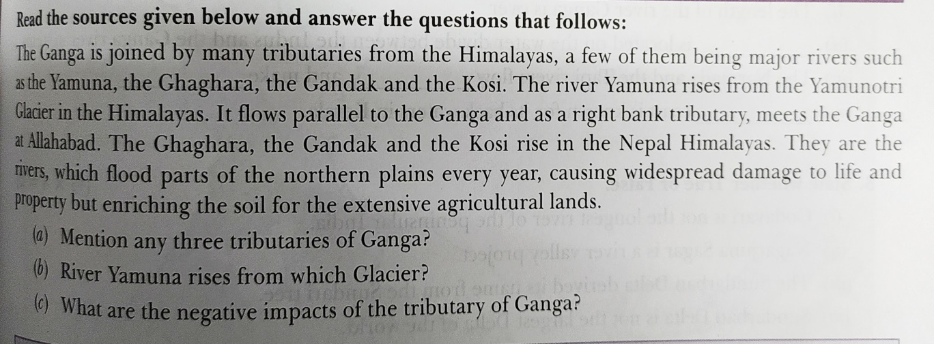
36. Answer the following questions of source based:
The main purpose of election is to give people a chance to choose the representative, the government and the policies they prefer. It is necessary to have a free and open discussion about who is better representative, which party will make a better government or what is good policy? This is what happens during the election campaign s. In our country such campaigns take place for two weeks period between the announcement of the final list of candidates and the date of polling. During this period the candidates contact their voters, political leaders address election meetings and political parties mobilise their supporters. This is also the period when newspapers and televisions news are full of election related stories and debates. But election campaign is not limited to these two weeks only. Political parties start preparing for elections months before they actually take place.
- What is the main purpose of election? (1)
- When does election campaign take place ? (1)
- What happens during the election? (2)
Section – F
Map pointing :
37 A Identify and label the following:
  - Name the country which is an allied power.
- Name the country which is the central power.
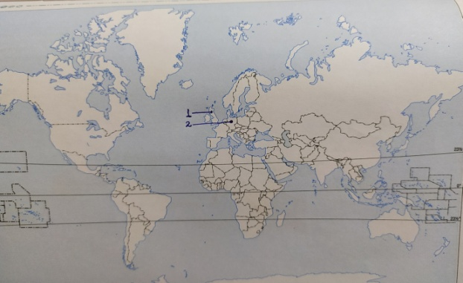
37B. Label and locate the following on the outline map of India. (Any 3).
  - Sambhar lake
  - River Ganga
  - Malabar Coast
  - State having lowest density population

